On Wednesday 19th July 2023 we held our Annual Tea Party
at The Spa Hotel.

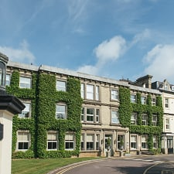

More than 60 members and guests attended. The Chairman gave special thanks to Dr Philip Whitbourn for signing copies of his book for those who purchased a copy and congratulated him on his recent Freedom of The Borough honour.

The Ranger, Dan Colborne gave in -depth answers to a number of questions in the popular
Q & A section.

Our Annual AGM followed the tea, was attended by a dozen or so members, plus Committee Officials. The afternoon was a success, and we must thank The Spa and Terry Coulthard for organising the event.

Chris Gurr

