HELPING HAND
Meet Nigel and members of the local archaeology team

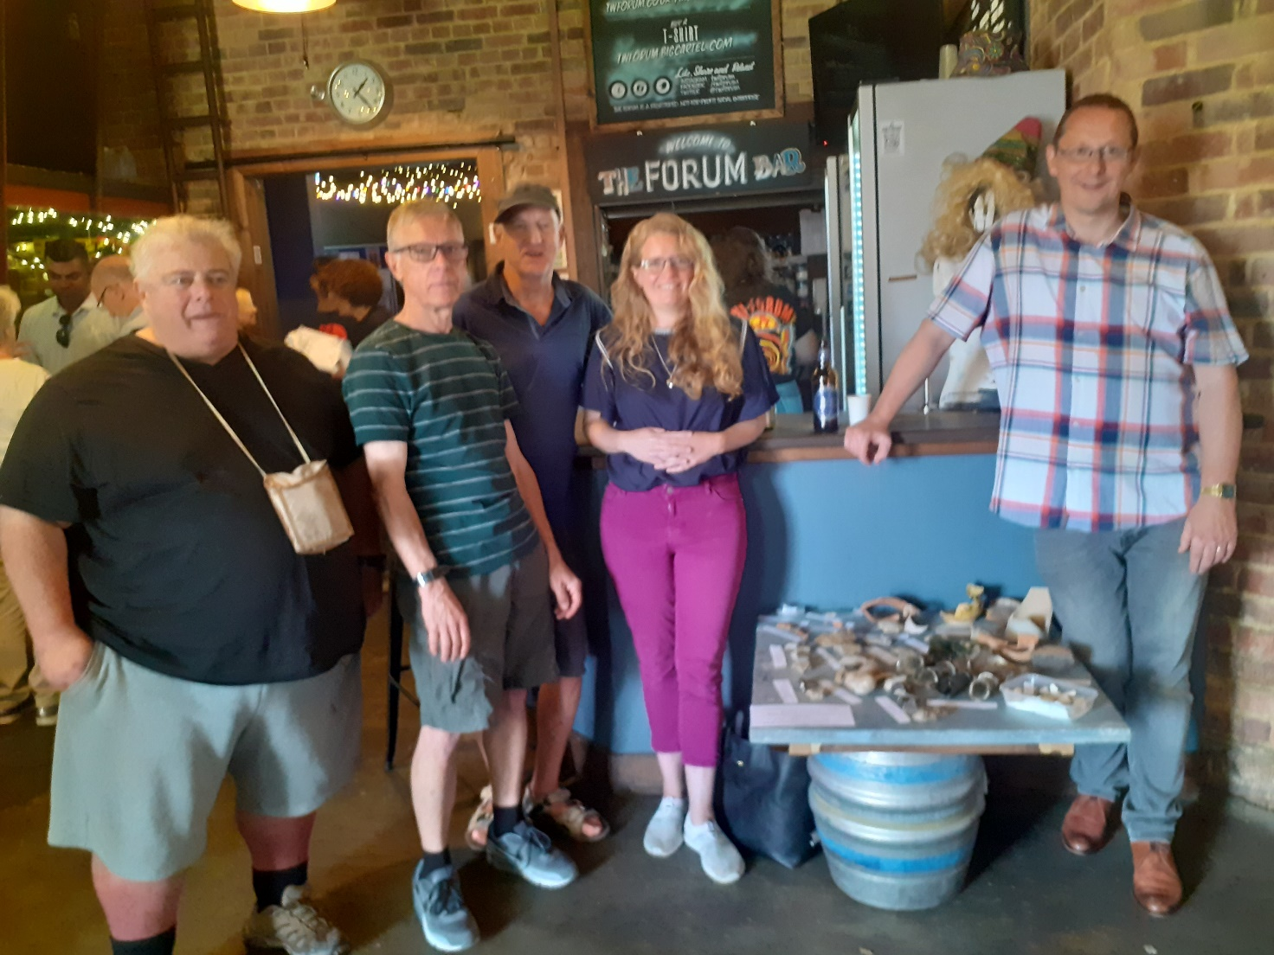
Meet some members of the local archaeology group West Kent Community Diggers (WKCD) who are looking for new volunteers for their current dig site on Rusthall common. No experience necessary just enthusiasm for our local heritage. We meet on-site on Wednesdays and Sundays throughout the year, weather permitting, and are currently uncovering both prehistoric and Medieval archaeology.

Anyone interested please contact Nigel wkdarchaeology@gmail.com for further information.

