Lending a Helping Hand

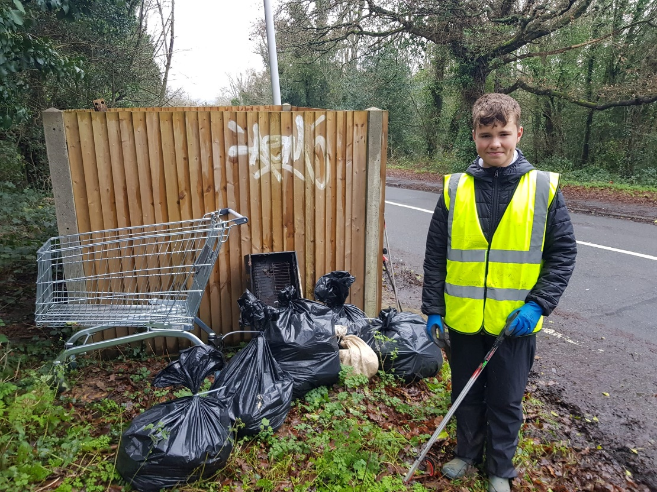

Meet one of our younger volunteers, Edward Brown a pupil from Bennett Memorial School, who has been participating in the DoE scheme. Edward has been assisting one of our more experienced volunteers, Mark Howden with his regular litter-pick sessions.
Thank you both for your hard work and thanks to the Venture, Rushall’s amazing hardware store for donating the sacks.
The pair managed to fill five black sacks and with the usual collection of bottles, cans, sweet wrappers crisp packets and takeaway containers and also found a golf jumper, a burner phone, a phone charger, an un-opened can of drink, a bank card, a BBQ, an M&S shopping trolley and a £5 note!
We welcome volunteers of all ages, just turn up to our next session, see details on our website. https://www.friendstothecommons.org/news--events.html or contact joypodbury@talktalk.net
All equipment supplied, safety briefings etc. covered before each session

