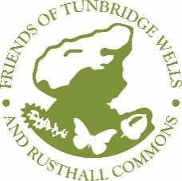
Friends of Tunbridge Wells & Rusthall Commons
Spring 2023
Ash dieback is the headline story for this month.
Tea Garden Lane has recently been cleared of diseased ash trees. The black centres shown in the photo confirms the presence of the disease. It is a sad sight, but it is also an opportunity, as more light should result in new plant life. A mix of young native species will be planted, to help improve the biodiversity.
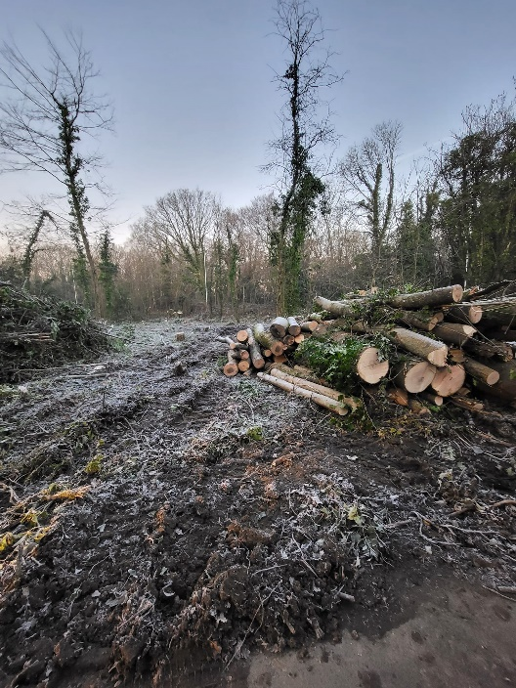
The cost is making a huge dent in the Conservators budget so, we are doing what we can to assist, but of course we are limited by our funds.
At the last committee meeting it was agreed the main projects for 2023 will be:-
Clearing trees, bracken, and scrub from the rocks in the Denny Bottom area. This work will be phased over the next three years. Management of the heather beds in the Marshall Plan area, this is to maximise wildlife value, improve the glade and open up the vista to the Trinity.
Other clearance and tree work includes an area close to the entrance of the racecourse, off Major York’s Road. Clearance of a small glade near Hungershall Park and control of sycamore growth. Look out for updates including photos in the next edition of Common Ground.
Diary Our popular family friendly Wildchild sessions will take place on the 4th end 5th April For more info. https://www.friendstothecommons.org/wild-child-23.html
The AGM will be combined with Afternoon Tea in July, date to be confirmed.
We have recently purchased a batch of yellow vests, which include our distinctive logo – See how good we look!
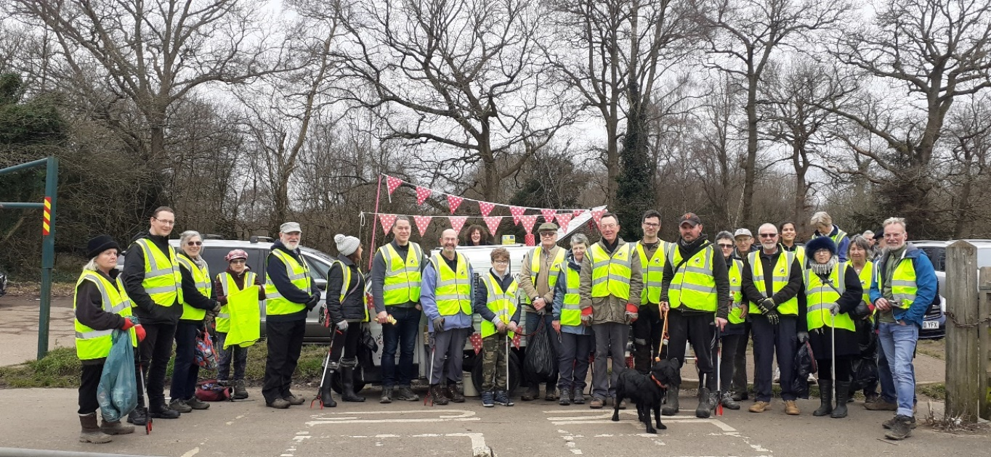
Volunteers
Our volunteers are making a huge difference – a massive thank you to you all! Over the winter months regular work parties have cleared areas of laurel, brambles, cutback overgrown gorse and cleared areas of various invasive species. As well as this, teams of volunteers have regularly turned out, to help keep the common clean and tidy by removing sacks and sacks of litter. It really has made a difference! If you would like to join us, just turn up, details on the website.
Meet one of our youngest helpers, Edward, who is one of our DoE volunteers. To read more about him and his amazing finds.
https://www.friendstothecommons.org/volunteer.html
Do you use Facebook? If so, would you be willing to develop the Friends of the Commons social media presence? Contact joypodbury@talktalk.net
We are seeking a Newsletter Editor, to join the committee contact Chris Gurr for more details. chris.gurr@yahoo.co.uk.

